**Preliminary Design Review**

**TEAM : ROBOT’S FEVER**

**COUNTRY : ROMÂNIA**

**Table of contents**

|  |  |  |
| --- | --- | --- |
| **Page** | | **Title** |
| 3 | | Progress report |
| 4 | | Progress statement for team profile |
| 5 | | Task list |
| 6 | | Detailed work progress |
|  | | Design document |
|  | | **Chapter I: Introduction** |
|  | | Robot’s Fever team |
|  | | Team task sharing |
|  | | Secondary mission description |
|  | **Chapter II: Cansat description** | |
|  | Mission overview | |
|  | Mechanical / Structural Design | |
|  | Software design | |
|  | Recovery system | |
|  | Ground support equipment | |
|  | **Chapter III: Project planning** | |
|  | Preliminary budget | |
|  | External support | |
|  | Cansat architecture and blueprints | |
|  | Test schedule | |
|  | **Chapter IV: Outreach** | |
|  | **Chapter V: Cansat requirements** | |

**Progress report**

**Progress statement**

Our CanSat is supposed to measure the temperature and pressure as a main mission and as secondary mission the level of beta and gamma radiation, the humidity level. Also as a secondary mission a GPS module will help us with the CanSat’s position and in combination with an accelerometer, a 3D map will be drawn**.** We’ve chosen to measure the radiation level in order to make a radiation exclusion map. The dew-point and the humidity level will be measured so that we can predict whether further rain will be radioactive.

We have connected on the Pro Micro board till now the temperature and pressure sensor, the temperature and humidity sensor, the GPS module, the accelerometer sensor, the radio transceiver, the 4800mA accumulator, the SD card and we are to connect the Geiger tube. As ground support, we are using an Arduino Uno board with a radio receiver, all connected to a laptop. We still have to build the receiver’s antenna and we haven’t finished building the housing structure yet.

**Task list**



**Detailed progress status**

At the beginning, we divided the team in small groups so we could have a better view upon the CanSat. After we chose the subgroups based on their highest skills we set the meeting’s dates and the time plan. We debated on how many secondary missions will be chosen and we decided on the radiation, the humidity, the accelerometer and the GPS. After this we made the 3D model and the blueprints. While the construction team was connecting the sensors on the board, the software development team was integrating the code. At first we had some problems testing the sensors because our USB cable and USB port were both damaged and we had to solve it. We worked on more computers so we were changing the cables and we figured out that two cables were broken. On one computer there were no cables which worked so we found out that the port was broken too. As well we had problems with the code because we initially failed connecting multiple sensors if they had different voltages. We burnt out a Pro Micro board as we used too many batteries connected in series. We thought we had a 5V board, when we actually had a 3.3V one.

As well we have troubles with the board internal memory because our sketch used too much memory and we have to optimize the code, especially the accelerometer one as it uses too many arrays.

We have tested the structure material made with thin aluminum by applying a seventy N force and the material collapsed, so we have the change this to a more durable metal like duralumin.

We don’t know yet how to connect two pins from the radio module to the mainboard, but we are close in finding a solution with the help of a radio-amateur teacher from Children’s Palace.

**Design document**

## Robot’s Fever team

Our team in alphabetical order:

* Buzgan Paul – 17 years old – ”Dragoș Vodă” National High School Câmpulung Moldovenesc

Paul is a talented web designer. He is also keen on maths and mechanical engineering. He loves to play basketball and he enjoys playing strategy based games.

* Diaconu Călin - 18 years old – ”Dragoș Vodă” National High School Câmpulung Moldovenesc

Calin loves maths, physics and he is interested in every aspect on the computer science field. He is our official photographer.

* Florescu Teodora - 17 years old – ”Dragoș Vodă” National High School

Teodora likes chemistry. She is good on making presentations and her main job in the team is to gather and process data. She loves to read and she is interested in painting.

* Hariga George - 17 years old – Military National High School ”Ștefan cel Mare” Câmpulung Moldovenesc

George is very good with computers especially with code integration. He is also keen on physics, maths and mechanical engineering. He loves to run and he listens electro and house music.

* Savin Alexandru - 17 years old – Military National High School ”Ștefan cel Mare” - Câmpulung Moldovenesc

Alex is interested in physics, maths, Computer Science, mechanical engineering and he is a former physics and chemistry national Olympic. This year he made it to the national linguistics Olympiad.

* Ursachi Radu - 17 years old – ”Dragoș Vodă” National High School Câmpulung Moldovenesc

Radu is our engineer. He really loves to assemble/disassemble things. He rides the bike and he sometimes tinker it.

Our team’s coordinator teacher is Măgurean Marius from Military National High School ”Ștefan cel Mare” Câmpulung Moldovenesc. He is a Computer Science teacher.

## Team Roles

The CanSat Flight Operations Team in alphabetical order

|  |  |  |
| --- | --- | --- |
| No. | Department | Name |
|  | Mission Manager | prof. Măgurean Marius |
| 2. | Design Team | Everybody  3 weekly meetings/2 hours/meeting |
| 3. | Construction Team | Buzgan Paul  Ursachi Radu  3 weekly meetings/3 hours/meeting  Indefined individual work |
| 4. | Integration Team | Buzgan Paul  Hariga George  Ursachi Radu  3 weekly meetings/2 hours/meeting  Indefined individual work |
| 5. | Software development Team | Diaconu Călin  Florescu Teodora  Hariga George  Savin Alexandru  5 weekly meetings/2 hours/meeting |
| 6. | Testing Team | Buzgan Paul  Diaconu Călin  Ursachi Radu  Each time after task completed |
| 7. | Data gathering Team | Florescu Teodora  Buzgan Paul  During tests and contest  Data manipulation – 2 times/week |
| 8. | Presentation Team | Florescu Teodora  Savin Alexandru  1 weekly meeting, contest |

## Secondary mission description

Our secondary mission is to measure the beta and gamma radiation level in the launch area. In addition, the can will bring information about orientation, determined by an accelerometer, but also humidity which together with temperature and pressure can compute other indices (e.g. dewpoint). All this will be correlated with latitude, longitude, altitude and time they were taken, determined by a GPS module. Information will be stored on can’s memory card and transmitted in real time via radio. After landing, the GPS module will help locating, unless it can be pursued during the fall.

We’ve chosen this mission inspired by the Fukushima’s events that took place in 2011. One problem was to determine how the radioactive clouds evolved in time and to draw an exclusion zone (evacuation zone) without sending people to measure that. So, we figured out that we can construct a remote control device who will measure and gather the necessary data. Due to limited cost, an entire fleet of cansats can be sent and, in case of contamination, they will be abandoned.

As well we will make a map of landing based on GPS and Accelerometer.

If we can finalize everything before time we will make our CanSat a rover as well, but this takes a lot of time for integrating with the other sensors and making it really well.

## 2.1. Mission overview

The CanSat is designed to fit in a regular 330ml juice can and will be launched from a plane, helicopter, drone or a rocket named Intrusion. At 1000 metres, the mini satellite will be released and will descend with an estimated speed of 8 m/s. While flying, the Cansat will measure the temperature, pressure and humidity, the level of beta and gamma radiation, its position with a GPS module. Data will be transmitted with a transceiver and will be also stored on a SD card. A receiver board will gather the data and a laptop will provide information based on the satellite measurements.

The CanSat is fuelled by a battery and will fly for approximately 120 seconds and data will be transmitted every second. A parachute will slow down the descent and the exterior material will be duralumin in order to withstand the 20g forces or more. The length of the parachute was obtained through precise computations.

The CanSat will have the following:

* Pro Micro board;
* Radio transceiver and antenna;
* Temperature and pressure sensor;
* Geiger counter (for beta and gamma radiation);
* GPS module (location, altitude, date, time);
* Temperature and humidity sensor;
* Accelerometer sensor;
* SD card;
* Battery;
* On/off button
* Voltage regulator;

Block diagram

**Microcontroller**

**Temperature and humidity sensor DHT11**

**Transmitter**

**Radiation sensor Geiger counter**

**GPS module**

**Barometic preasure and temperature sensor BMP180**

**Ground Station**

Accelerometer sensor

Power source

SD card

## 2.2. Mechanical / Structural Design

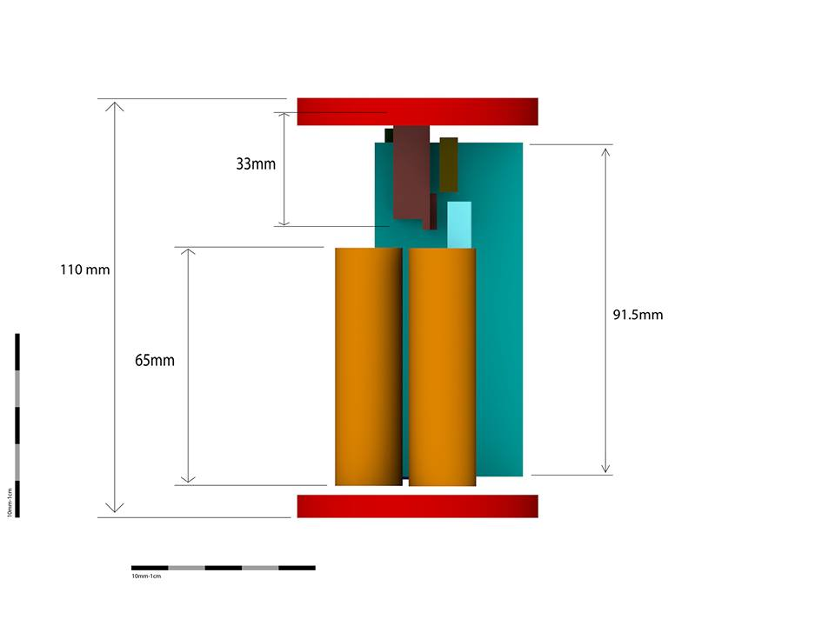

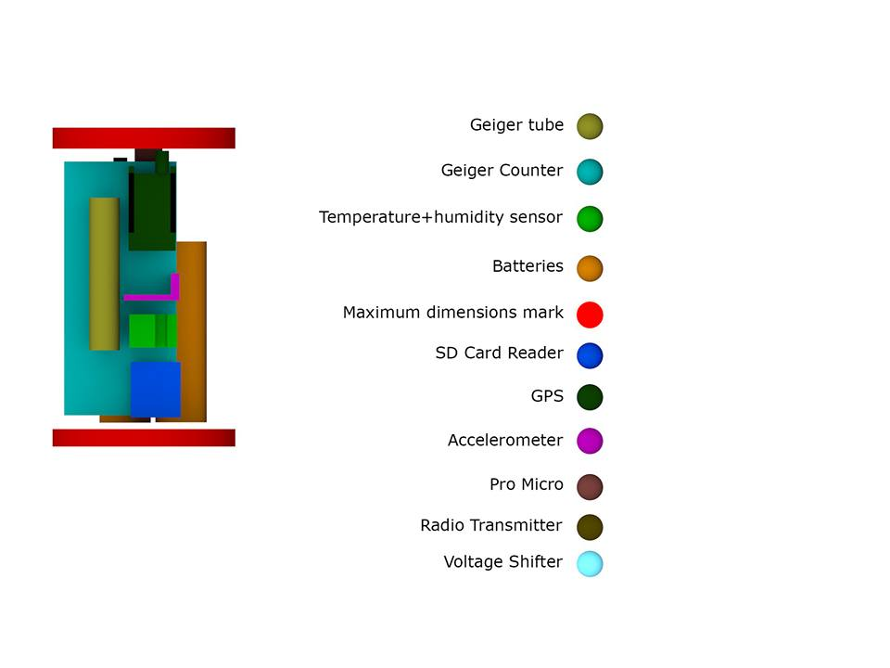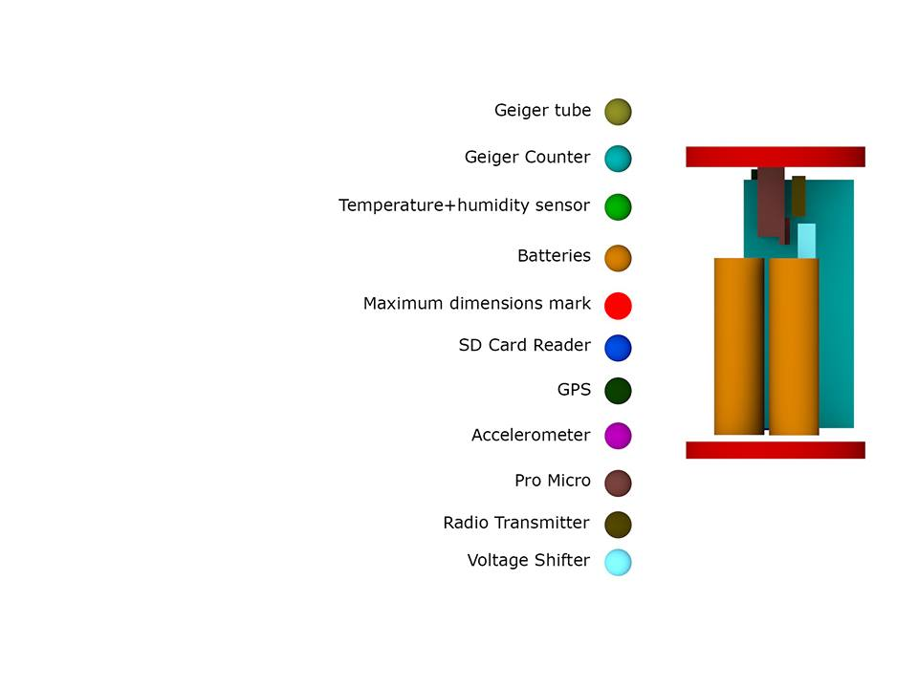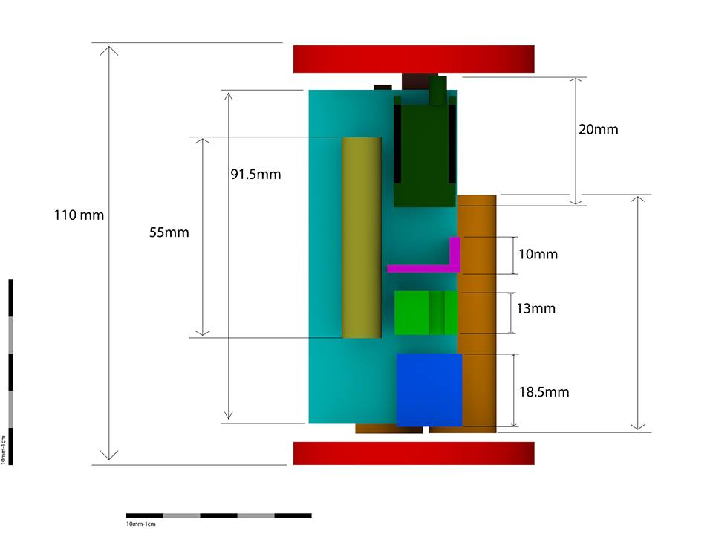 2.3. Electrical Design

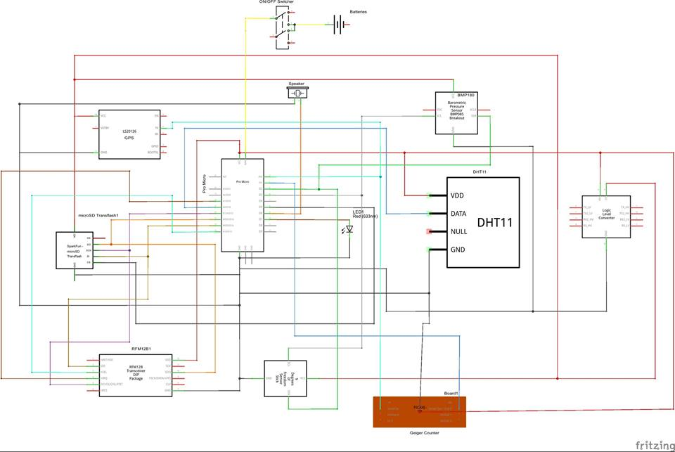

## 2.4. Software design

We made a sketch which contains the code for every sensor and module. We had trouble with the GPS as it could not transmit data simultaneously with the other sensors. We solved it by stopping other sensors transmission while the GPS is working. Consequently we have an if…else statement in our sketch.

The sensors are expected to transmit data to the SD card where it will be stored in a text file format .The transmitter is expected to send the data to the ground station where it will be collected by a receiver and manipulated on a laptop through the Processing application.

We used a modified version of C++ programming language for the sensors and modules and Java programming language in order to work with Processing.

## 2.5. Recovery system

For recovery system we worked on the parachute which was made in the children’s house club based on the next calculations:

I)

 is the approximate force made by the difference of pressure at the surface of the parachute.

P= is the dynamic pressure of the air tube.

S is the surface of the spherical calotte of the parachute.

=S

=

=6πrv (we approximate the tube as being a sphere)

II)

mg=+4πrv+S

m=0.35Kg

=1,205

=1,8*

g=9,8

0,35*9,8=1,205*74,75*+220,425**+*S

We consider v=8

III)

We calculate the medium acceleration, until the reach of the speed v=8

H=1000m

mg-=m*(initially the speed is 0 so all the terms which contains v disappear)

0,35*9,8-1,205*74,75*=m*

3,43-0,009= 0,35*

=9,8

==4,9

V=at

8=4,9t

T=1,63s

In 1,63s it’s reached the speed =8

h=

h=6,509m

H-h=*

=124,186s

T=t+=126 s

In conclusion our CanSat will land in 126 seconds and will have a 0,43  surface.

As well we use our GPS module for locating our CanSat.

## 2.6. Ground support equipment

On ground we will have a laptop which is going to receive raw data through another Arduino Uno board with a receiver board attached on it and which is going to process them using the software called Processing. The data is going to be retransmitted to the ProMicro board and stored on the SD card. The data is going to be transmitted from a board to another using a ground antenna. It is possible for us to make a remote controller, but this is not sure yet, because we don’t know yet if we are going to do a rover or if we will start and stop the sensors on command.

## 3.1. Time schedule

1. The tasks were divided (as shown in the team task sharing), the design of the mini-satellite was discussed and we made the 3D model simulation. The secondary mission was discussed, which will be constituted by the measurement of the radiations and the construction of a rover. It was proposed the saving of data on a SD card.
2. We worked on the parachute together with the team from the aeromodel club. The parachute was tested by throwing a can of juice filled with sand from 6 meters above the ground. Everything was filmed and is uploaded on team’s youtube channel, facebook page and web page. Because of the wind the cansat stuck and the parachute was damaged.
3. The parachute was repaired, we worked at the website which contains a brief description of the team, pictures and videos with our activity, the temperature and humidity sensors(DHT11), temperature, pressure and altitude(BMP180) and the GPS(Venus) for the primary and secondary mission. The website was launched and the sensors were tested. We disused about building the antenna .
4. The team met with purpose of estimating the CanSat’s behavior during flight and to calculate the ideal size for the final parachute. The calculations where made with the help of our physics tutor. While some of us worked with our teacher, the others glued the pins necessary for the other sensors.
5. We tried to program the servomotors and we established the final design for the CanSat. During the attempt of getting electrical energy from the batteries for the board we burned out the Arduino Micro. Consequently we had to buy a new Arduino Micro board.
6. Our project was presented to our colleagues from one of the highschools, therefore the number of likes for our Facebook page and views of our posted videos increased. The pictures taken during the presentation are to be uploaded on our web page.
7. We could not connect the Step-Down Regulator D24V5F3 properly. The cause of this failure was detected but the solution was to be found. We proceeded to connect the Brick RFM12B and the Transflash microSD to the Micro Arduino board.
8. The solution for the previous day problem was found. When we tried to connect all our CanSat’s components to the Arduino Micro board, we realized that there is not enough memory on the board for the code of all of our sensors and the other parts. Several solutions were proposed including the raw transmission of data, Arduino code shortage and programming the sensors in such a way that we can start the data transmission and stop it whenever we needed it to also conserve the energy of the batteries.

## 3.2.1. Budget

Purchased items*

|  |  |  |  |  |
| --- | --- | --- | --- | --- |
| No. | Name | Units | Price/unit | Price (Ron) |
| 1. | MinIMU-9 v3 Gyro, Accelerometer, and Compass (L3GD20H and LSM303D Carrier) | 1 | 111 | 111 |
| 2. | microSD Transflash | 1 | 48 | 48 |
| 3. | PCB board | 3 | 9 | 27 |
| 4. | Pin Headers | 5 | 2 | 10 |
| 5. | Male/Male jumper wires | 3 | 8 | 24 |
| 6. | Male/Female jumper wires | 3 | 9 | 27 |
| 7. | Female/Female jumper wires | 3 | 9 | 27 |
| 8. | Female pin headers | 5 | 5 | 25 |
| 9. | Regulator Step-Down | 1 | 28 | 28 |
| 10. | Li-Ion 4800mA Accumulators | 4 | 15 | 60 |
| 11. | Geiger-Muller tube | 1 | 107,21 | 107,21 |
| 12. | Geiger Counter Kit | 1 | 100,83 | 100,83 |
| 13. | 3.7V battery charger | 2 | 8 | 16 |
| 14. | Pro Micro 5V/16MHz - ATMega 32U4 | 1 | 116 | 116 |
| 15. | Switcher TSSM1022A2 | 1 | 5,44 | 5,44 |
| 16. | Venus GPS | 1 | 216 | 216 |
| 17. | Temperature and humidity sensor | 1 | 27 | 27 |

Given items

|  |  |  |  |  |  |
| --- | --- | --- | --- | --- | --- |
| No. | Name | Giver | Units | Price/unit | Price |
| 1. | Pro Micro Controller | Cosmos Kit | 1 | 178,4 | 178,4 |
| 2. | Temperature and pressure sensor | Cosmos Kit | 1 | 66,9 | 66,9 |

In the future we may buy an engine for the rover and the other components for making our Cansat a rover as well.

## 3.2.2. External support

We received monetary help from the Military High School’s association called „Asociatia Voievodul Stefan a Colegiului Militar Stefan cel Mare” and from National High School „Dragos Voda”.

We were helped with the parachute’s computations by the physics teacher Gulii Catalina and with the parachute assembling by mister Catargiu from Children’s Palace.

A Teacher from Children’s Palace helped us with the soldering by providing us a soldering hammer.

## 3.3. Test plan

## 4. Outreach programme

## 5. Requirements

|  |  |
| --- | --- |
| **Characteristics** | **Figure** |
| Height of the CanSat[mm] |  |
| Mass of the CanSat[g] |  |
| Diameter of the CanSat[mm] |  |
| Length of the recovery system [mm] |  |
| Flight time scheduled [s] |  |
| Calculated descent rate |  |
| Radio frequency used [MHz] |  |
| Power consumption [W] |  |
| Total cost [€] |  |

On behalf of the team I confirm that our CanSat complies with all the requirements established for the 2016 European CanSat competition in the official Guidelines, APPENDIX 1 of this document.

Signature, place and date

# APPENDIX 1 The CanSat Requirements

The CanSat hardware and missions must be designed to the following requirements and constraints:

[1] All the components of the CanSat must fit inside a standard soda can (115 mm height and 66 mm diameter), with the exception of the parachute. An exemption can be made for radio antennas and GPS antennas, which can be mounted externally (on the top or bottom of the can, not on the sides), based on the design.

N.B. The rocket payload area has 4.5 cm of space available per CanSat, along the can’s axial dimension (i.e. height), which must accommodate all external elements including: parachute, parachute attachment hardware, and any antennas.

[2] The antennas, transducers and other elements of the CanSat cannot extend beyond the can’s diameter until it has left the launch vehicle.

[3] The mass of the CanSat must be between 300 grams and 350 grams. CanSats that are lighter must take additional ballast with them to reach the 300 grams minimum mass limit required.

[4] Explosives, detonators, pyrotechnics, and flammable or dangerous materials are strictly forbidden. All materials used must be safe for the personnel, the equipment and the environment. Material Safety Data Sheets (MSDS) will be requested in case of doubt.

[5] The CanSat must be powered by a battery and/or solar panels. It must be possible for the systems to be switched on for four continuous hours.

[6] The battery must be easily accessible in case it has to be replaced/recharged.

[7] The CanSat must have an easily accessible master power switch.

[8] Inclusion of a retrieval system (beeper, radio beacon, GPS, etc.) is recommended.

[9] The CanSat should have a recovery system, such as a parachute, capable of being reused after launch. It is recommended to use bright coloured fabric, which will facilitate recovery of the CanSat after landing.

[10] The parachute connection must be able to withstand up to 1000 N of force. The strength of the parachute must be tested, to give confidence that the system will operate nominally.

[11] For recovery reasons, a maximum flight time of 120 seconds is recommended. If attempting a directed landing then a maximum of 170 seconds flight time is recommended.

[12] A descent rate between 8 m/s and 11 m/s is recommended for recovery reasons. In case of attempting a directed landing, a lower descent rate of 6m/s is recommended.

[13] The CanSat must be able to withstand an acceleration of up to 20 g.

[14] The total budget of the final CanSat model should not exceed 500€. Ground Stations (GS) and any related non-flying item will not be considered in the budget. More information regarding the penalties in case of exceeding the stated budget can be found in the next section.

[15] In case of sponsorship, all the items obtained should be specified in the budget with the corresponding costs on the market at that moment.

[16] The CanSat must be flight-ready upon arrival to the launch campaign. A final technical inspection of the CanSats will be done by authorised personnel before launch

**Cansat requirements**

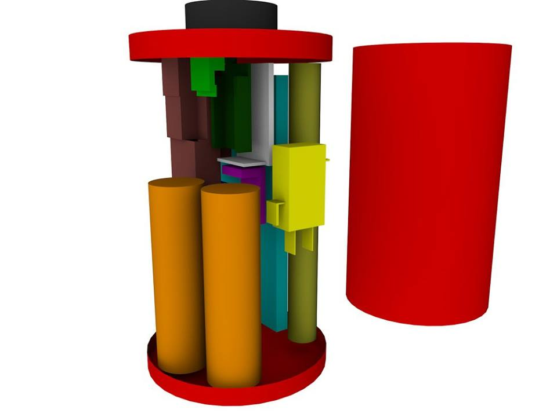In order to meet the cansat required seizes, we have designed a 3D model in Cinema 4D.

To be updated with specifics (antenna, gps antenna integration)

Total mass (item1 + item2 + ….item n estimation)

As detaliated in model, the battery is easy accessible and we have a master power switch.

As a beeper we have a phone’s speaker attached to our cansat. Moreover, we have a GPS sensor who tracks the cansat coordinates.

For our parachute to withstand a 1000N of force, we made the following calculations:

Nina’s formulas (to be completed……)

Acceleration 20g – how?